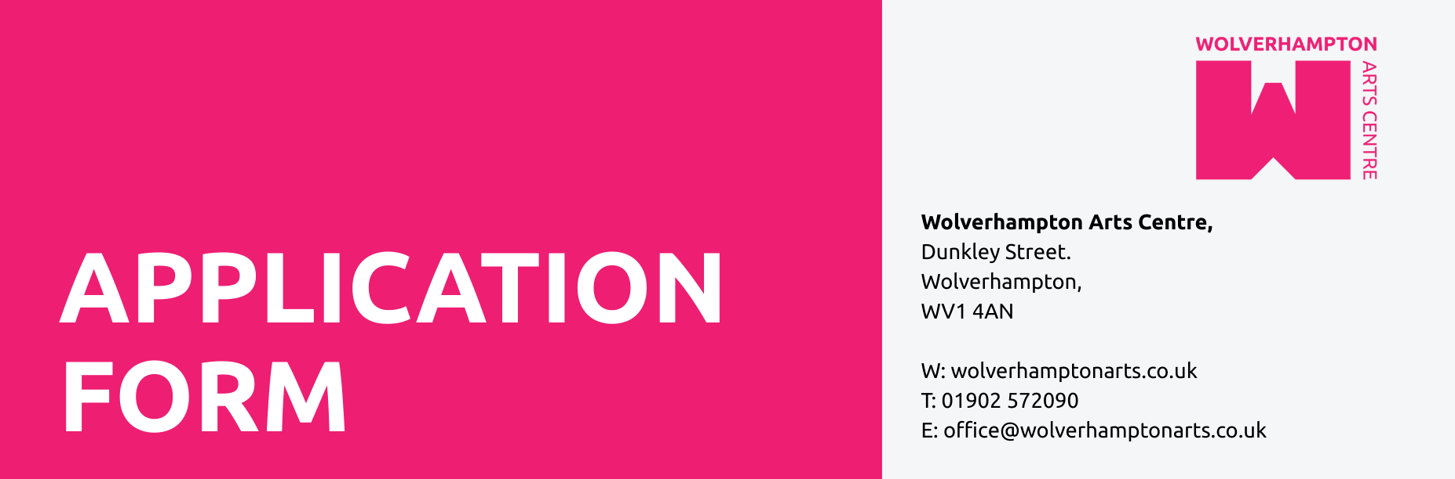

Application Form

This form should be completed as fully as possible. Please email it to office@wolverhamptonarts.co.uk.
The Personal Information Page will be separated from your application and all shortlisting will be done without looking at these details. If you would like to submit the application in another format please contact us on 01902 572090 to discuss how we can accommodate your needs.

Personal Information

Name:

Address:

Tel No: (day) (evening)

Email:

N.I. Number: (if none, give details of nationality)

Are you entitled to work in the UK?

Do you have any convictions not considered spent
under the Rehabilitation of Offenders Act 1974? YES/NO

(If yes please give details)
DECLARATION

I declare that, to the best of my knowledge, the information given in this application is correct and I understand that it will be treated as part of any subsequent Contract of Employment.

SIGNED: DATE:

Education / Qualifications

Details of schools/colleges/universities attended, dates and qualifications achieved. A degree is not a requirement for this position, and we encourage you to bring in as wide a range of educational and training experiences as you can.

Employment History

Please give details of your employment history (paid or voluntary) or equivalent experience, starting with your most recent post, giving names of the organisation, job titles, responsibilities, whether paid or voluntary, dates and reason for leaving.

List any other skills, qualifications, or interests which may be appropriate for the post:

Additional Information

Please explain why you are applying for this post, stating what qualities you think you can bring to the job and any additional information you feel supports your application. If you feel you have covered everything you can leave this blank, but if there are things that you feel could enable us to get to know you better then do add it here.

References

Please provide contact details for two referees (this should include your most recent employer or a recent client if freelance):

 | Reference 1 | Reference 2
Name
Company/Organisation
Job/Title
Address
Post code
Phone
Email
Relationship to you
Length of notice required

Are you happy for us to contact your current employer before interview? YES/NO

Equal Opportunities Information

This form will be separated from your application

How did you hear about this post?
Do you consider yourself Male/Female/Other/Prefer not to say
Do you consider yourself disabled/non-disabled/prefer not to say
How would you describe your ethnic background?

